GCSE Chemistry required practical activity: Making salts

Teachers’ notes

Materials

In addition to access to general laboratory equipment, each candidate needs:

* 40cm3 1.0M dilute sulfuric acid
* copper (II) oxide powder.

Technical information

If crystallising dishes are not available, petri dishes (without lids) make good substitutes. If small conical flasks are not available, a second small beaker is an acceptable replacement.

To prepare 1.0M dilute sulfuric acid, consult CLEAPSS Recipe Book 98 and Guide L195.

40cm3 of dilute acid will react with approximately 3.2g copper (II) oxide powder, but more than this will be used due to the excess added.

Additional information

Students should be warned not to boil the acid. If students add copper (II) oxide to hot acid in large portions, the resulting frothing may go over the top of the beaker. Students should be reminded of the importance of good filtering technique (e.g. correct paper folding, liquid level not above top edge of filter paper). Students will also need to be reminded not to allow the water bath to boil dry.

The procedure may require two 60 minute lessons to complete. If so, it is suggested that the filtrate is retained at the end of the first lesson for evaporation during the second.

Students must not be allowed to take their crystals home. The waste crystals can be recycled to make up new copper (II) sulfate stock solutions.

Risk assessment

* Risk assessment and risk management are the responsibility of the centre.
* Safety goggles should be worn throughout.
* 1.0M dilute sulfuric acid (IRRITANT) is covered by Hazcard 98A.
* copper(II) oxide (HARMFUL) is covered by Hazcard 26.
* copper(II) sulfate (HARMFUL) is covered by Hazcard 27C.

Trialling

The practical should be trialled before use with students.

Student sheet

Method

**You are provided with the following:**

* 40 cm3 1.0 M dilute sulfuric acid
* copper (II) oxide powder
* spatula
* glass rod
* 100 cm3 beaker
* Bunsen burner
* tripod
* gauze
* heatproof mat
* filter funnel and paper
* clamp stand
* conical flask
* 250 cm3 beaker
* evaporating basin
* crystallising dish.

**Read these instructions carefully before you start work.**

1. Measure 40 cm3 sulfuric acid into the 100 cm3 beaker.

The volume does not need to be very accurate, so you can use the graduations on the beaker.

1. Set up the tripod, gauze and heatproof mat. Heat the acid **gently** using the Bunsen burner until it is almost boiling. Turn off the Bunsen burner.

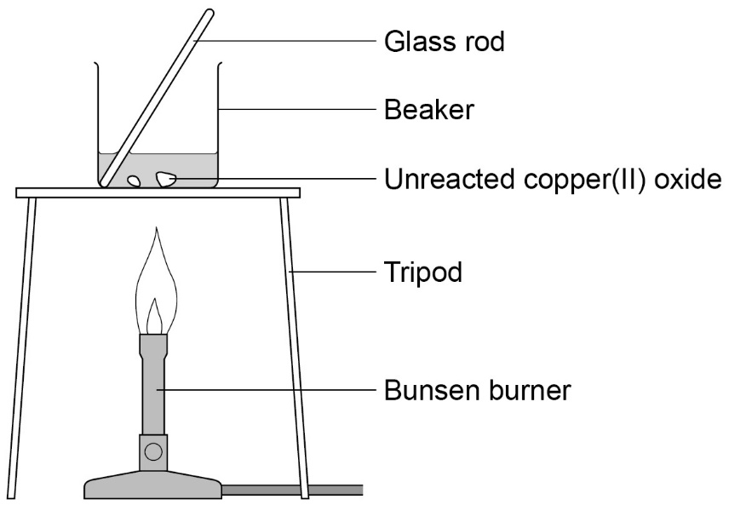

1. Use the spatula to add **small** amounts of copper (II) oxide powder. Stir with the glass rod.

Continue to add copper (II) oxide if it keeps disappearing when stirred. When the

copper (II) oxide disappears the solution is clear blue.

1. Stop adding the copper (II) oxide when some of it remains after stirring.

Allow apparatus to cool completely.

1. Set up the filter funnel and paper over the conical flask. Use the clamp stand to hold the funnel.

Filter the contents of the beaker from step **3**.

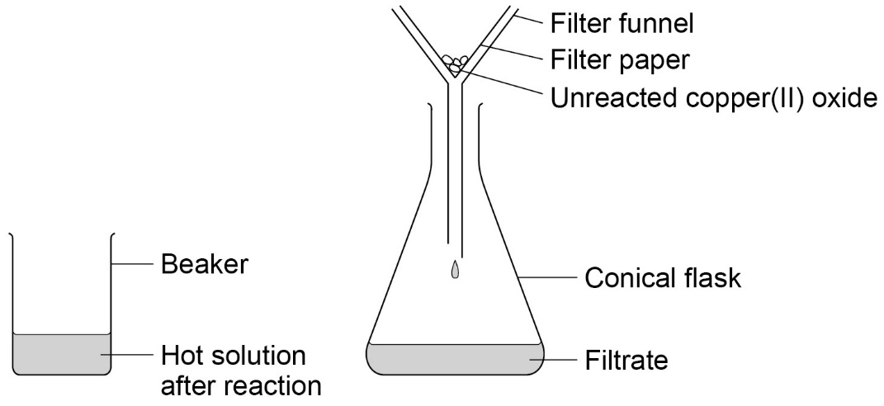

1. When filtration is complete, pour the contents of the conical flask into the evaporating basin.

Evaporate this gently using a water bath (250 cm3 beaker with boiling water) on the tripod and gauze (see diagram). Stop heating once crystals start to form.

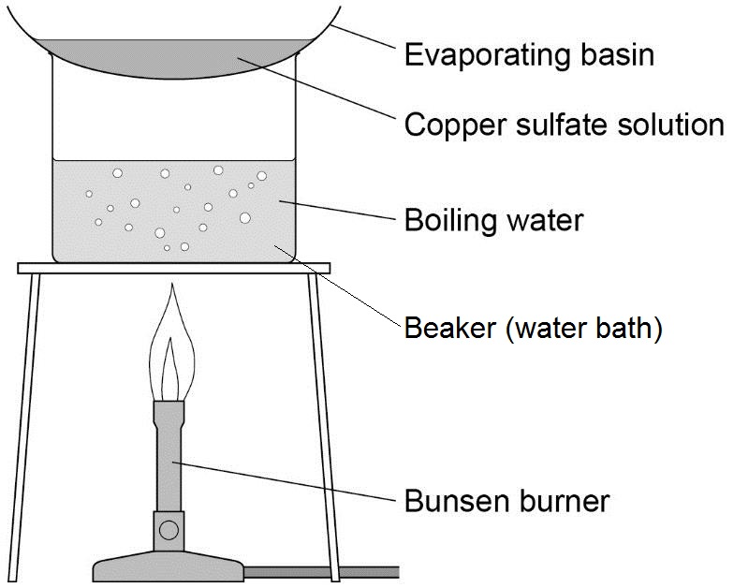

1. Transfer the remaining solution to the crystallising dish. Leave this in a cool place for **at least 24 hours**.
2. Remove the crystals from the concentrated solution with a spatula. **Gently** pat the crystals dry between two pieces of filter paper.

These are pure dry crystals of copper (II) sulfate.

GCSE Chemistry required practical activity: Electrolysis

Teachers’ notes

Materials

In addition to access to general laboratory equipment, each student needs:

* 0.5M copper(II) chloride solution
* 0.5M sodium chloride solution
* 0.5M copper(II) sulfate solution
* 0.5M sodium sulfate solution
* petri dish lid with bored holes
* two carbon rod electrodes with support bungs
* two crocodile/4mm plug leads
* low voltage power supply
* blue litmus paper
* tweezers.

Technical information

To prepare 0.5M copper (II) chloride solution and 0.5M copper (II) sulfate solution, consult CLEAPSS Recipe Book 31 and Guide L195.

To prepare 0.5M sodium chloride solution, consult CLEAPSS Recipe Book 82 and Guide L195.

Preparation of sodium sulfate solution is not covered by the Recipe Book.

Small petri dish lids fit 100cm3 beakers well and can be drilled out at 180o spacing to take the two electrodes. If the carbon rods are then fitted with holed bungs that are positioned to rest on the lid above the holes, the rods will be stabilised well and the risk of short circuits will be much reduced.

Proprietary electrolysis cells are available, and can be substituted if available.

Additional information

Chlorine is produced during the first two electrolyses. Students should be warned not to inhale it, and the laboratory should be well ventilated. Limiting the p.d. to 4v and the electrolysis times to 5 minutes will minimize the risk of chlorine exposure.

Much longer times will be needed to collect enough oxygen and hydrogen for testing. If a Hofmann voltameter is available, it could be set up with sodium sulfate (or sulfuric acid) at the beginning of the lesson. This will usually produce enough oxygen and hydrogen for testing by the end of the lesson.

Much frustration can be avoided if the crocodile leads are tested for electrical continuity before this activity.

Trialling

The practical should be trialled before use with students.

GCSE Chemistry required practical activity: Electrolysis

Student sheet

Method

**You are provided with the following:**

* copper(II) chloride solution
* copper(II) sulfate solution
* sodium chloride solution
* sodium sulfate solution
* 100 cm3 beaker
* petri dish lid
* two carbon rod electrodes
* two crocodile/4 mm plug leads
* low voltage power supply
* blue litmus paper
* tweezers.

**Read these instructions carefully before you start work.**

1. Pour copper (II) chloride solution into the beaker to about 50 cm3.
2. Add the lid and insert carbon rods through the holes. **The rods must not touch each other**.

Attach crocodile leads to the rods. Connect the rods to the **dc (red and black)** terminals of a low voltage power supply.

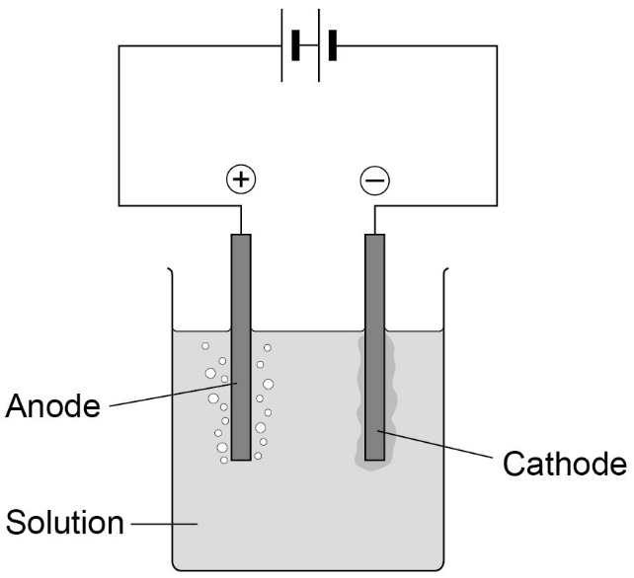

1. Select 4 V on the power supply and switch on.
2. Look at both electrodes. Is there bubbling at neither, one or both electrodes?
3. Use tweezers to hold a piece of blue litmus paper in the solution next to the positive electrode (the one connected to the red terminal). You will need to lift the lid temporarily to do this.

Write your observations in the first blank row of the table below. What is this element?

|  |  |  |  |  |
| --- | --- | --- | --- | --- |
| **Solution** | **Positive electrode (anode)** | | **Negative electrode (cathode)** | |
| **Observations** | **Element formed** | **Observations** | **Element formed** |
| **Copper (II) chloride** |  |  |  |  |
| **Copper (II) sulfate** |  |  |  |  |
| **Sodium**  **chloride** |  |  |  |  |
| **Sodium**  **sulfate** |  |  |  |  |

1. After no more than five minutes, switch off the power supply.

Examine the negative electrode (the one connected to the black terminal). Is there evidence of a metal coating on it? What could it be?

Record your results in the table.

1. Clean the equipment carefully.

Repeat steps **1‒6** using solutions of:

* copper (II) sulfate
* sodium chloride
* sodium sulfate.

**Additional information**

Gas produced at the positive electrode which does **not** bleach blue litmus paper, is oxygen. The amounts produced are usually too small to identify by testing.

If a gas is produced at the negative electrode, it is hydrogen. The amounts produced are usually too small to identify by testing.

GCSE Chemistry required practical activity: Temperature changes

Teachers’ notes

Materials

In addition to access to general laboratory equipment, each student needs:

* 2 M dilute hydrochloric acid
* 2 M sodium hydroxide solution
* Expanded polystyrene cups and lids with thermometer holes
* 0-110oC thermometers.

Technical information

To prepare 2 M dilute hydrochloric acid, consult CLEAPSS Recipe Book 43 and Guide L195.

To prepare 2 M sodium hydroxide solution, consult CLEAPSS Recipe Book 85 and Guide L195.

30cm thermometers are preferable to 15cm as they are easier to read over the small temperature increases expected and additionally the bulk of the thermometer scale will be above the hole in the lid.

Lids for polystyrene cups can be purchased and perforated; otherwise wooden lids can easily be constructed.

Additional information

Students may need to be reminded to keep thermometer bulbs fully immersed whilst making measurements.

Additional guidance may need to be provided to students regarding the drawing of the two lines of best fit so that they intersect.

The solutions used are quite concentrated in order to produce reasonable temperature changes. 2M sodium hydroxide is particularly hazardous to the eyes. The risk assessment should take account of the ability and behaviour of the group and concentrations lowered if necessary. For example, 10cm3 portions of 1M sodium hydroxide could be substituted.

Trialling

The practical should be trialled before use with students.

**GCSE Chemistry required practical activity: Temperature changes**

**Student sheet**

**Method**

**You are provided with the following:**

* 2 M dilute hydrochloric acid
* 2 M sodium hydroxide solution
* expanded polystyrene cup and lid
* 250 cm3 beaker
* 10 cm3 measuring cylinder
* 50 cm3 measuring cylinder
* thermometer.

**Read these instructions carefully before you start work.**

1. Use the 50 cm3 measuring cylinder to put 30 cm3 dilute hydrochloric acid into the

polystyrene cup.

1. Stand the cup inside the beaker. This will make it more stable.
2. Use the thermometer to measure the temperature of the acid. Record it in the first blank column of the table such as the one below.
3. Put 5 cm3 sodium hydroxide solution into the 10 cm3 measuring cylinder.
4. Pour the sodium hydroxide into the cup. Fit the lid and gently stir the solution with the thermometer through the hole.

When the reading on the thermometer **stops changing**, write the temperature in the next space in the table.

1. Repeat steps **4** and **5** to add further 5 cm3 amounts of sodium hydroxide to the cup. A total of 40 cm3 needs to be added.

The last few additions should produce a temperature fall rather than a rise.

1. Repeat steps **1–6** and record the results in the second blank column of the table.
2. Calculate the **mean** maximum temperature reached for each of the sodium hydroxide volumes. Record these means in the third blank column.

|  |  |  |  |
| --- | --- | --- | --- |
| **Total volume of sodium hydroxide**  **added in cm3** | **Maximum temperature in oC** | | |
| **First trial** | **Second trial** | **Mean** |
| 0 |  |  |  |
| 5 |  |  |  |
| 10 |  |  |  |
| 15 |  |  |  |
| 20 |  |  |  |
| 25 |  |  |  |
| 30 |  |  |  |
| 35 |  |  |  |
| 40 |  |  |  |

1. Plot a graph with:

* ‘Mean maximum temperature in oC’ on the y-axis
* ‘Total volume of sodium hydroxide added in cm3’ on the x-axis.

Draw two straight lines of best fit:

* one through the points which are increasing
* one through the points which are decreasing.

Ensure the two lines are extended so they cross each other.

1. Use the graph to estimate how much sodium hydroxide solution was needed to neutralise

25 cm3 dilute hydrochloric acid.

GCSE Chemistry required practical activity: Rates of reaction

Teachers’ notes

**Activity 1: Colour change**

Materials

In addition to access to general laboratory equipment, each candidate needs:

* 40g/dm3 sodium thiosulfate solution.
* 2.0 M dilute hydrochloric acid
* conical flask (100 cm3)
* printed black paper cross
* stopclock

Technical information

To prepare 40g/dm3 sodium thiosulfate solution, consult CLEAPSS Recipe Book 87 and Guide L195. The concentration is specified in g/dm3 rather than mole/dm3 to simplify graph plotting for students. However, if it is desired that a Higher Tier group work in mole/dm3 then the base thiosulfate solution should be 0.2 M. The diluted solutions prepared by students will then be 0.16, 0.12, 0.08 and 0.04 mole/dm3

To prepare 2.0 M dilute hydrochloric acid, consult CLEAPSS Recipe Book 43 and Guide L195.

Printed crosses may give a greater likelihood of students obtaining reproducible results between groups.

Additional information

This required practical should form the basis of a complete investigation and will probably require two 60 minute laboratory lessons to complete.

Sulfur dioxide is released during the reaction which can exacerbate breathing difficulties in people with pre-existing conditions such as asthma. The laboratory should be well ventilated. Consult CLEAPPS Guide L195 for additional safety information.

Trialling

The practical should be trialled before use with students

**Activity 2: Volume of gas**

Materials

In addition to access to general laboratory equipment, each candidate needs:

* magnesium ribbon cut into 3 cm lengths
* dilute hydrochloric acid, 1.0 M
* safety goggles
* each group of students will need:
* conical flask (100 cm3)
* single-holed rubber bung and delivery tube to fit conical flask (Note 1)
* trough or plastic washing-up bowl (Note 2)
* measuring cylinders (100 cm3), 2
* clamp stand, boss and clamp
* stopclock
* graph paper.

Technical information

The magnesium ribbon needs to be cleaned by rubbing lengths of the ribbon with fine sandpaper to remove the layer of oxidation. To prepare Hydrochloric acid, HCl (aq) - see CLEAPSS Hazcard 47a and CLEAPSS Recipe Book 43. The bungs in the flasks need to be rubber, since corks are too porous and will leak.

Additional Information

Gas syringes can be used instead of troughs of water and measuring cylinders. But these are expensive and are probably best used by the teacher in a demonstration. Syringes should not be allowed to become wet, or the plungers will stick.

Trialling

The practical should be trialled before use with students.

**GCSE Chemistry required practical activity: Rates of reaction**

**Student sheet**

**Method**

**Activity 1: Observing colour change**

**You are provided with the following:**

* 40 g/dm3 sodium thiosulfate solution
* 2.0 M dilute hydrochloric acid
* 10 cm3 measuring cylinder
* 100 cm3 measuring cylinder
* 100 cm3 conical flask
* printed black paper cross
* stop clock.

**Read these instructions carefully before you start work.**

1. Use a measuring cylinder to put 10 cm3 sodium thiosulfate solution into the conical flask.

Use the measuring cylinder to then add 40 cm3 water. This dilutes the sodium thiosulfate solution to a concentration of 8 g/dm3.

Put the conical flask on the black cross.

1. Put 10 cm3 of dilute hydrochloric acid into the 10 cm3 measuring cylinder.
2. Put this acid into the flask. At the same time swirl the flask gently and start the stopclock.
3. Look down through the top of the flask. Stop the clock when you can no longer see the cross.

**Take care to avoid breathing in any sulfur dioxide fumes.**

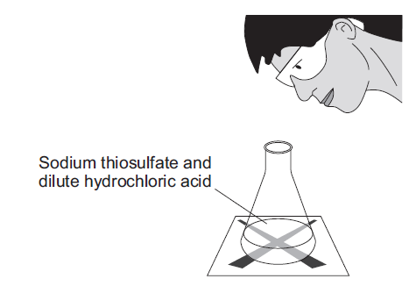

1. Write the time it takes for the cross to disappear in the first blank column of the table such as the one below. Record the time **in seconds**.

You will need to multiply any minutes by 60 and then add the extra seconds.

|  |  |  |  |  |
| --- | --- | --- | --- | --- |
| **Concentration of sodium thiosulfate in g/dm3** | **Time taken for cross to disappear in seconds** | | | |
| **First trial** | **Second trial** | **Third trial** | **Mean** |
| 8 |  |  |  |  |
| 16 |  |  |  |  |
| 24 |  |  |  |  |
| 32 |  |  |  |  |
| 40 |  |  |  |  |

1. Repeat steps **1‒5** four times, **but in step 1 use:**

* 20 cm3 sodium thiosulfate + 30 cm3 water (concentration 16 g/dm3)
* 30 cm3 sodium thiosulfate + 20 cm3 water (concentration 24 g/dm3)
* 40 cm3 sodium thiosulfate + 10 cm3 water (concentration 32 g/dm3)
* 50 cm3 sodium thiosulfate + no water (concentration 40 g/dm3).

1. Then repeat the **whole investigation** (steps **1–5**) twice more.

Record the results in the second and third blank columns of the table.

1. Calculate the **mean** time for each of the sodium thiosulfate concentrations. Leave out anomalous values from your calculations.

Record the means in the fourth blank column.

1. Plot a graph with:

* ‘mean time taken for cross to disappear in seconds’ on the y-axis
* ‘Sodium thiosulfate concentration in g/dm3’ on the x-axis.

Draw a smooth curved line of best fit.

What can you say about the effect of the independent variable (concentration) on the dependent variable (time taken for the cross to disappear)? What were your control variables?

Compare your results with those of others in the class. Is there evidence that this investigation is reproducible?**Activity 2: Measuring the volume of gas produced**

**You are provided with the following:**

* Safety goggles
* conical flask (100 cm3)
* single-holed rubber bung and delivery tube to fit conical flask
* trough or plastic washing-up bowl
* two measuring cylinders (100 cm3)
* clamp stand, boss and clamp
* stop clock
* graph paper
* magnesium ribbon cut into 3 cm lengths
* dilute hydrochloric acid, (2.0 M, and 1.0 M).

**Read these instructions carefully before you start work.**

1. Measure 50 cm3 of 2.0 M hydrochloric acid using one of the measuring cylinders. Pour the acid into the 100 cm3 conical flask.
2. Set up the apparatus as shown in the diagram.

Half fill the trough or bowl with water.

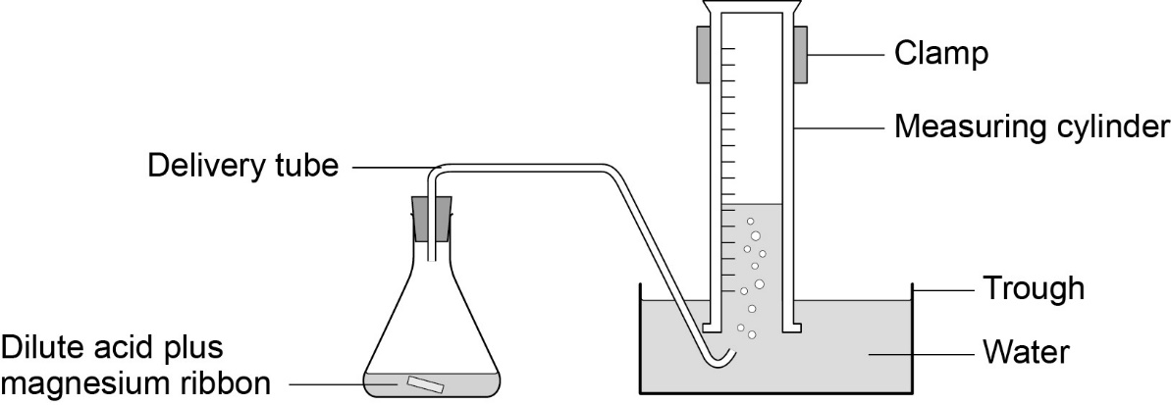

1. Fill the other measuring cylinder with water. Make sure it stays filled with water when you turn it upside down.
2. When you are ready, add a 3 cm strip of magnesium ribbon to the flask, put the bung back into the flask as quickly as you can, and start the stopclock.
3. Record the volume of hydrogen gas given off at suitable intervals (eg 10 seconds) in a table such as the one below.

Continue timing until no more gas appears to be given off.

|  |  |
| --- | --- |
| **Time in seconds** | **Volume of gas produced for 2.0 M hydrochloric acid in cm3** |
| 10 |  |
| 20 |  |
| 30 |  |
| 40 |  |
| 50 |  |
| 60 |  |
| 70 |  |
| 80 |  |
| 90 |  |
| 100 |  |

1. Repeat steps **1-5** using 1.0 M hydrochloric acid.
2. Plot a graph with:

* ‘Volume of gas produced in cm3 (for 2.0 M hydrochloric acid)’ on the y-axis
* ‘Time in seconds’ on the x-axis.

1. Draw a smooth, curved line of best fit.
2. Plot a curve for 1.0 M hydrochloric acid on the same graph.
3. Use this graph to compare the rates of reaction of 1.0 M and 2.0 M hydrochloric acid with magnesium.
4. Compare your results with the data collected in **Activity 1.**
5. Use kinetic theory to explain your findings.

GCSE Chemistry required practical activity: Chromatography

Teachers’ notes

Materials

In addition to access to general laboratory equipment, each candidate needs:

* Four known food colourings labelled **A–D**
* Unknown food colouring labelled **U**
* Rectangle of chromatography paper
* Capillary melting point tubes.

Technical information

There are several brands of food colouring available. It will be necessary to experiment to obtain a type which gives good results. The unknown mixture should contain two of the known food colouring and a third colour **not** from **A–D**. Best results will be obtained if **A–D** are single dyes and not mixtures themselves.

Additional information

It is suggested that chromatography paper is pre-cut for student use so that it will not touch the beaker walls (if it does, capillary rise at the edges will distort the solvent front).

Melting point tubes take up food dye by capillary attraction and are a convenient way of making small reproducible spots.

Wet chromatography paper is difficult to take measurements from. Because of the drying time involved it may be necessary to make measurements and do calculations during the following lesson.

Students should be told to resist the temptation to move or touch the beaker once the experiment is under way.

A lid is sometimes suggested for good results, especially when the solvent is volatile, but is not essential with water. However, to illustrate good practice, if desired, a petri dish or lid makes a suitable lid. Cut-outs in the wall can be made at 180o to each other to clear the ends of the glass rod.

Trialling

The practical should be trialled before use with students.

GCSE Chemistry required practical activity: Chromatography

Student sheet

Method

**You are provided with the following:**

* 250 cm3 beaker
* Glass rod
* A rectangle of chromatography paper
* Four known food colourings labelled **A**-**D**
* An **unknown mixture** of food colourings labelled **U**
* Glass capillary tubes.

**Read these instructions carefully before you start work.**

1. Use a ruler to draw a horizontal pencil line 2 cm from a short edge of the chromatography paper.

Mark five pencil spots at equal intervals across the line. Keep at least 1 cm away from each end.

1. Use a glass capillary tube to put a small spot of each of the known colourings on four of the pencil spots. Then use the glass capillary tube to put a small spot of the unknown mixture on the 5th pencil spot.

Try to make sure each spot is no more than 5 mm in diameter.

Label each spot **in pencil**.

1. Pour water into the beaker to a depth of **no more than 1 cm**.
2. Tape the edge of the chromatography paper to the glass rod. The paper needs to be taped at the end furthest from the spots.

Rest the rod on the top edge of the beaker. The bottom edge of the paper should dip into the water.

**Ensure that the:**

* **pencil line is above the water surface**
* 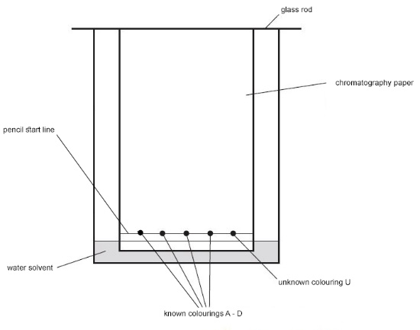**sides of the paper do not touch the beaker wall**

1. Wait for the water solvent to travel at least three quarters of the way up the paper. Do **not** disturb the beaker during this time.

Carefully remove the paper. Draw another pencil line on the dry part of the paper as close to the wet edge as possible.

1. Hang the paper up to dry thoroughly.
2. Measure the distance in mm between the two pencil lines. This is the distance travelled by the water solvent.

Measure and record the same distance for each food colouring in the table below.

|  |  |  |  |
| --- | --- | --- | --- |
| **Food colouring** | **Distance travelled in mm** | | **Rf value** |
| **Solvent** | **Spot** |
| **A** |  |  |  |
| **B** |  |  |  |
| **C** |  |  |  |
| **D** |  |  |  |

1. For each of the four known colours, measure the distance in mm from the bottom line to the centre of each spot. Write each measurement in the table.
2. Use the following equation to calculate the Rf value for each of the known colours.

$${\text{R}}_{\text{f}}\text{ = }\frac{\text{distance}\text{ moved by substance}}{\text{distance moved by solvent}}$$

Write the calculated values in the table.

1. Match the spots in mixture **U** with those from **A–D**. Use the colour and distance travelled to help you.

Which of colourings **A–D** are in mixture **U**?

Are there any other colourings in mixture **U** which do **not** match **A–D**?

GCSE Chemistry Required practical activity: Water purification

Teachers’ notes

Materials

In addition to access to general laboratory equipment, each candidate needs:

* 10 cm3 salt water (concentration unimportant but should give good positive test results for sodium and chloride ions)
* nichrome wire mounted in handle
* 0.4 M dilute nitric acid
* 0.05 M silver nitrate solution
* A few ice cubes

Technical information

Nichrome wires can be mounted in lengths of glass capillary tube to form a handle. Two right- angled delivery tubes can be linked with rubber tubing to create the double right-angle required. The tubes should be pre-inserted into suitable rubber bungs.

Although only a small quantity of water needs to be distilled, enough needs to be present in the flask to avoid it boiling dry and cracking.

To prepare 0.4 M dilute nitric acid, consult CLEAPSS Recipe Book 61 and Guide L195.

To prepare 0.05 M silver nitrate solution, consult CLEAPSS Recipe Book 77 and Guide L195.

**Additional information**

Students will need to be cautioned to remove the heat source if it seems likely the salt water will boil over through the delivery tube. They should also be told to keep the delivery tube at least 2cm from the bottom of the collecting test tube; otherwise the distillate level may rise above it, creating the possibility of suck-back when heating is discontinued.

**Risk assessment**

* Risk assessment and risk management are the responsibility of the centre.
* Safety goggles should be worn throughout.
* 0.4 M dilute nitric acid (IRRITANT) is covered by Hazcard 67.
* 0.05 M silver nitrate (LOW RISK at this concentration) is covered by Hazcard 87.

**Trialling**

The practical should be trialled before use with students.

**GCSE Chemistry Required practical activity: Water purification**

**Student sheet**

**Method**

**You are provided with the following:**

* 10 cm3 salt water
* Bunsen burner
* tripod
* gauze
* heatproof mat
* 250 cm3 beaker
* clamp stand
* 250 cm3 conical flask
* delivery tube with bung
* test tubes ×2
* ice
* test tube rack
* nichrome wire
* dilute nitric acid
* silver nitrate solution.

**Read these instructions carefully before you start work.**

1. Pour around 1 cm depth of the salt water into a test tube in the rack.

Dip the nichrome wire into this solution, and then hold the tip of the wire in a blue Bunsen burner flame. Record your observation in the table such as the one below.

A yellow flame test confirms the presence of sodium ions.

|  |  |
| --- | --- |
| **Flame test** | **Nitric acid and silver nitrate** |
| **Salt water** |  |  |
| **Distilled water** |  |  |

1. Add a few drops of dilute nitric acid to this solution. Then add 1 cm depth of silver nitrate solution. Again, record your observations in the table.

A white precipitate with nitric acid and sliver nitrate solution confirms the presence of chloride ions.

1. Place the remaining salt water in the conical flask. Set up the apparatus for distillation as shown in the diagram.

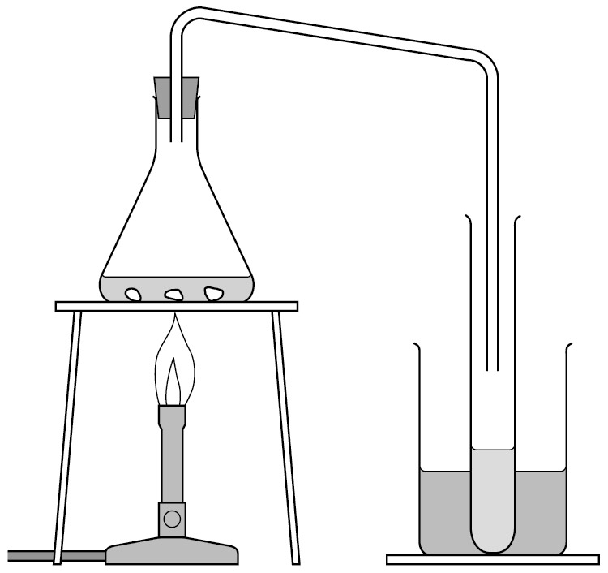

Make sure the conical flask is held on the tripod and gauze using the clamp stand.

Put a mixture of ice and water in the beaker surrounding the test tube.

1. Boil the water using the Bunsen burner. Then reduce the heat so that the water boils gently.

Distilled water will collect in the cooled test tube. Collect about 1 cm depth of water in this way, then stop heating.

1. Repeat the tests in steps **1** and **2** again using the distilled water. Make sure that the nichrome wire and test tube have been cleaned.

Again, record your results in the table.

GCSE Physics required practical activity: Resistance

Teachers’ notes

Materials

In addition to access to general laboratory equipment, each student needs access to:

* a battery or suitable power supply
* ammeter or multimeter
* voltmeter or multimeter
* crocodile clips
* resistance wire eg constantan of different diameters
* metre ruler
* connecting leads
* wire-wound resistors, eg 10 Ω

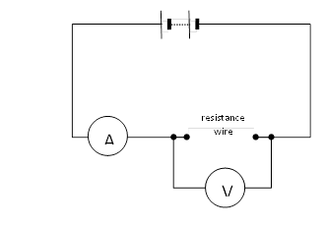

V

A

Technical information

The most straightforward way to investigate resistance is to use an ohmmeter. However, this practical requires the students to make a circuit, measure current and potential difference and calculate the resistance.

There are at least 5 different experiments that could be carried out: the circuit is the same in each case. However, this practical focuses on the variation of resistance with length.

Use a length of resistance wire (just over a metre of 22 swg constantan). Attach it to a metre ruler using tape. Attach a crocodile clip to one end (the zero end) of the material. Attach the other crocodile clip to the wire. The students vary the length of wire by moving this crocodile clip and record the length of wire, current and potential difference.

For the second activity, any suitable value of resistors may be used, but if wire wound resistors are used, this should alleviate any potential problems with overheating.

Give students two resistors of the same value and ask them to connect them into the two circuits shown above. By measuring the voltage across the resistors and the current through them (placing the meters in the positions shown in the circuit diagrams) they can calculate the total resistance of the circuit.

As an extension, you could ask them to put three identical resistors in series and then in parallel.

As a further extension you could ask them to measure the current at different points in the circuit.

Additional information

The resistance of the wire is proportional to its length. A graph of resistance against length should be a straight line through the origin. This experiment is a good one to use to discuss zero error as it is hard to attach the crocodile precisely to the zero end of the wire, and there will be some contact resistances. The potential difference will not vary very much during the experiment. Use a low value of potential difference particularly for the short length of wire as the current will increase significantly and the wire can get quite hot. The wire should be fairly thin to give decent values of resistance.

Lock variable power supply unit to low voltages, if possible. Use heatproof mats.

Trialling

The practical should be trialled before use with students.

GCSE Physics required practical activity: Resistance

Student sheet

Method

**You are provided with the following:**

* a battery or suitable power supply
* ammeter or multimeter
* voltmeter or multimeter
* crocodile clips
* resistance wire eg constantan of different diameters attached to a metre ruler
* connecting leads.

**Read these instructions carefully before you start work.**

1. Connect the circuit.

It may be helpful to start at the positive side of the battery or power supply. This may be indicated by a red socket.

1. Connect a lead from the red socket to the positive side of the ammeter.
2. Connect a lead from the negative side of the ammeter (this may be black) to the crocodile clip at the zero end of the ruler.

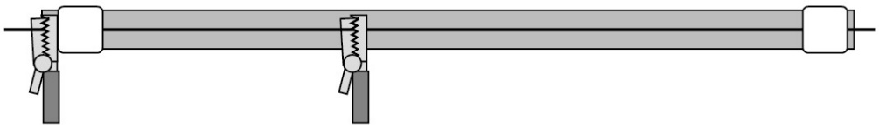

1. Connect a lead from the other crocodile clip to the negative side of the battery.

The main loop of the circuit is now complete. Use this lead as a switch to disconnect the battery between readings.

1. Connect a lead from the positive side of the voltmeter to the crocodile clip the ammeter is connected to.
2. Connect a lead from the negative side of the voltmeter to the other crocodile clip.

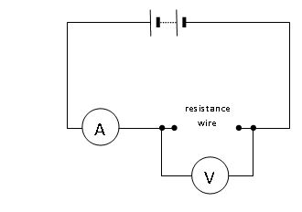

1. Record on a table the:

* length of the wire between the crocodile clips
* the readings on the ammeter
* the readings on the voltmeter.

You will need four columns in total.

|  |  |  |  |
| --- | --- | --- | --- |
| **Length of wire in cm** | **Potential difference in V** | **Current in A** | **Resistance in ** |
|  |  |  |  |

1. Move the crocodile clip and record the new ammeter and voltmeter readings. Note that the voltmeter reading may not change.

Repeat this to obtain several pairs of meter readings for different lengths of wire.

1. Calculate and record the resistance for each length of wire using the equation:

|  |  |  |
| --- | --- | --- |
| resistance in  | = | potential difference in V |
| current in A |

1. Plot a graph with:

* ‘Resistance in ’ on the y-axis
* ‘Length of wire in cm’ on the x-axis

1. You should be able to draw a straight line of best fit although it may not go through the origin.

Can you account for the extra resistance?

**Activity 2: Investigating resistors in series and in parallel**

**You are provided with the following:**

* a battery or suitable power supply
* ammeter or multimeter
* voltmeter or multimeter
* crocodile clips
* two 10Ω resistors
* connecting leads.

**Read these instructions carefully before you start work.**

1. Connect the circuit for two resistors in series, as shown in the diagram.
2. Switch on and record the readings on the ammeter and the voltmeter.

Voltmeter

Switch

R1

Ammeter

Power supply

R2

1. Use these readings to calculate the total resistance of the circuit.
2. Now set up the circuit for two resistors in parallel.
3. Switch on and record the readings on the ammeter and the voltmeter.

R2

Switch

Voltmeter

Ammeter

R1

Power supply

1. Use these readings to calculate the total resistance of the circuit.
2. With one single resistor in the circuit, the total resistance would be 10 ohms. What is the effect on the total resistance of adding:
   1. another identical resistor in series
   2. another identical resistor in parallel?
3. You could also try setting up a circuit with three resistors in series and one with three resistors in parallel.
4. What conclusions can you come to about the effect of adding resistors
   1. In series
   2. In parallel

GCSE-Physics required practical activity: I-V Characteristics

Teachers’ notes

Materials

In addition to access to general laboratory equipment, each student needs access to:

* ammeter and milliammeter, or multimeter
* voltmeter or multimeter
* component holders
* 12 V, 24 W lamp e.g. a ray box lamp
* resistor, for example 100 Ω, 1 W
* diode and protective resistor (eg 10 Ω)
* rheostat eg 10 Ω, 5 A
* connecting leads.

Technical information

There are many different electricity kits available and the students should use what is familiar to them. If using multimeters it may be helpful to tape over the connections not in use.

When using the diode, the students will need to use a protective resistor. They should still be able to connect the voltmeter across the diode (ie the resistor and diode should not be soldered together). This resistor should be labelled ‘P’ to distinguish it from the other resistor.

If a lab pack is used for the power supply this can remove the need for the rheostat as the pd can be varied directly.

The voltage should not be allowed to get so high as to damage the components.

Additional information

There are three separate experiments.

The exception is the diode as it will need to be protected to prevent the current through it getting too big. It also behaves differently depending on the polarity of the supply. Due to the low currents through it, a milliammeter will need to be used.

The students will record the current through each component for different values of p.d. The p.d. will be varied using a rheostat, although a variable power supply may be used.

The students will plot a graph of current against pd. This is what is meant by a characteristic. There is a tendency for some to think that the gradient of this graph is the resistance. In fact the resistance at any point on the graph is the inverse of the gradient of a line from that point to the origin.

A

V

A

V

mA

V

Risk assessment

* Risk assessment and risk management are the responsibility of the centre.
* Care should be taken as components, particularly lamps, are likely to get quite hot. The mains lead should be checked for damage before a lab pack is used by a student.

Trialling

The practical should be trialled before use with students.

GCSE Physics required practical activity: I-V Characteristics

Student sheet

Method

**You are provided with the following:**

* ammeter and milliammeter, or multimeter
* voltmeter or multimeter
* component holders
* 12 V, 24 W lamp eg a ray box lamp
* resistor
* diode and protective resistor (eg 10 Ω)
* rheostat eg 10 Ω, 5 A
* connecting leads.

**Read these instructions carefully before you start work.**

**Activity 1: The characteristic of a resistor**

1. Connect the circuit. It may be helpful to start at the positive side of the battery or power supply. This may be indicated by a red socket.
2. Connect a lead from the red socket to the positive side of the ammeter.

A

V

1. Connect a lead from the negative side of the ammeter (this may be black) to one side of the resistor.
2. Connect a lead from the other side of the resistor to the variable resistor.
3. Connect a lead from the other side of the variable resistor to the negative side of the battery.

The main loop of the circuit is now complete. Use this lead as a switch to disconnect the battery between readings.

1. Connect a lead from the positive side of the voltmeter to the side of the resistor the ammeter is connected to.
2. Connect a lead from the negative side of the voltmeter to the other side of the resistor.
3. Record the readings on the ammeter and voltmeter in a suitable table.
4. Adjust the variable resistor and record the new ammeter and voltmeter readings. Repeat this to obtain several pairs of readings.
5. Swap the connections on the battery. Now the ammeter is connected to the negative terminal and variable resistor to the positive terminal.

The readings on the ammeter and voltmeter should now be negative.

1. Continue to record pairs of readings of current and potential difference with the battery reversed.
2. Plot a graph with:

* ‘Current in A’ on the y-axis
* ‘Potential difference in V’ on the x-axis.

As the readings include negative values the origin of your graph will be in the middle of the graph paper.

1. You should be able to draw a straight line of best fit through the origin. This is the characteristic of a resistor.

**Read these instructions carefully before you start work.**

**Activity 2: the characteristic of a lamp**

1. Swap the leads on the battery back to their original positions.
2. Replace the resistor with the lamp.

If you are making the circuit from the beginning, follow steps 1-7 in the procedure for the resistor above. For these instructions, use a lamp in place of the resistor.

A

V

1. The lamp will get hot. Take care not to touch it.
2. Follow steps **8‒11** in the procedure for the resistor above. Remember to swap the leads on the battery to obtain negative readings.
3. Plot a graph with:

* ‘Current in A’ on the y-axis
* ‘Potential difference in V’ on the x-axis.

Again the origin will be in the middle of the paper.

Draw a curved line of best fit for your points.

**Read these instructions carefully before you start work.**

**Activity 3: the characteristic of a diode**

1. Swap the leads on the battery back to their original positions.
2. If you can, reduce the battery potential difference to less than 5 V.
3. Remove the lead from the positive side of the battery. Connect it to the extra resistor labelled **P**.
4. Connect the other end of resistor **P** to the positive side of the battery.
5. Replace the ammeter with a milliammeter

**or**

change the setting on the multimeter.

V

mA

1. Replace the lamp with the diode. Connect the positive side of the diode to the milliameter.
2. Repeat steps **1–6** above to obtain pairs of readings of potential difference and current for the diode.
3. Plot a graph with:

* ‘Current in A’ on the y-axis
* ‘Potential difference in V’ on the x-axis.

The origin will probably be in the middle of the bottom of your graph paper.

There should not be any negative values of current.

GCSE Physics required practical activity: Density

Teachers’ notes

Materials

In addition to access to general laboratory equipment, each student needs access to:

For the regular shaped solid objects:

* 30 cm ruler marked off in mm
* digital balance
* materials kits ie various regular shaped objects made of iron, copper, aluminium.

For the irregular shaped solid objects:

* digital balance
* displacement can and something to stand it on (eg a brick)
* measuring cylinders
* 250 ml beaker of water and an extra empty beaker
* paper towels
* cotton or thin string
* various irregular shaped objects.

For the liquids:

* digital balance
* 250 ml beaker
* suitable liquid eg sugar solution.

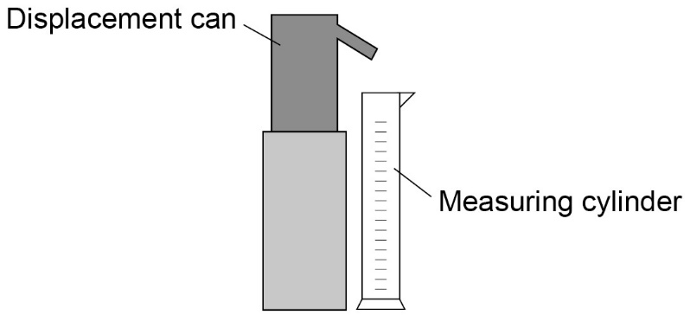

Ideally the digital balance should have a range of 1 kg in 1 g steps.

The experiments are relatively straightforward although the measurement of the densities of the liquids and the irregular objects may create a bit of a mess.

The experiments may be best done as part of a circus – so that everyone uses the different density measuring techniques.

You may want to label the solid objects for easy identification.

The displacement can spout is likely to be too low to fit a measuring cylinder underneath it; use a brick or something similar to stand the displacement can on. Alternatively they can tip the measuring cylinder so that it goes under the spout, but they may knock the spout when moving it.

Additional information

There are three separate experiments. The density of regular objects focuses on the use of a millimetre scale ruler and the calculations of volume and density. Students use their value of density to identify the material of the object being measured.

In the second experiment students measure the volume by displacement. This can be done by lowering the object into a sufficiently large measuring cylinder and noting the change in volume reading. However, a displacement can allows the use of narrower and therefore more precise measuring cylinders to measure the volume. The students should choose a measuring cylinder and justify their choice.

The density of liquid experiment does not make use of specific gravity bottles. It is a basic technique and students identify a liquid from its density.

Trialling

The practical should be trialled before use with students.

GCSE Physics required practical activity: Density

Student sheet

Method

**Activity 1: Regular shaped objects**

**You are provided with the following:**

* 30 cm ruler marked off in mm
* digital balance
* regular shaped objects.

**Read these instructions carefully before you start work.**

1. For each object measure the:

* length
* width
* height.

1. Record your results in a table.

Include columns for volume, mass, density and substance.

* volume
* mass
* density
* substance.

1. Measure the mass of each object using the digital balance. Record the results.
2. Calculate and record the volumes (length × width × height).
3. Calculate and record the densities (mass ÷ volume).
4. Use the table below to identify the substance each object is made from.

|  |  |  |  |  |  |  |
| --- | --- | --- | --- | --- | --- | --- |
| **Substance** | **Aluminium** | **Zinc** | **Iron** | **Copper** | **Gold** |  |
| Density in g/cm3 | 2.7 | 7.1 | 7.9 | 8.9 | 19.3 |  |

**Activity 2: Irregular shaped objects.**

**You are provided with the following:**

* digital balance
* displacement can and something to stand it on (eg a brick)
* various measuring cylinders
* beaker of water and an extra empty beaker
* paper towels
* cotton or thin string
* irregularly shaped objects.

**Read these instructions carefully before you start work.**

1. Measure the mass of one of the irregular shaped objects.
2. Record your result in a table.

It will need columns for:

* volume
* density
* mass
* substance.

1. Place a displacement can on a brick. Put an empty beaker under the spout and fill the can with water. Water should be dripping from the spout.
2. Wait until the water stops dripping. Then place a measuring cylinder under the spout instead of the beaker.

Choose the measuring cylinder you think will give the most precise reading.



1. Tie the object to a piece of cotton. Very carefully lower it into the displacement can so that it is completely submerged.

Collect all of the water that comes out of the spout in the measuring cylinder.

1. Measure and record the volume of the collected water. This volume is equal to the volume of the object.
2. Calculate and record the density of the object.

Try to find out what substance it is made from.

1. Repeat steps **1‒7** for some other objects.

Remember to refill the can each time.

**Activity 3 – liquids**

**You are provided with the following:**

* digital balance
* 250 ml beaker
* 100 ml measuring cylinder
* suitable liquid eg sugar solution.

**Read these instructions carefully before you start work.**

1. Measure the mass of the empty beaker.
2. Record your results in a table.

Your table will need columns for the:

* mass of the empty beaker
* mass of the beaker with the liquid in
* mass of the liquid
* volume of the liquid
* density of the liquid.

1. Pour about 100 ml of liquid into the measuring cylinder.

Measure and record the volume.

1. Pour this liquid into the beaker.

Measure and record the mass of the beaker and liquid.

1. Calculate and record the volume of the liquid.
2. Calculate the density of the liquid.
3. The density of water is 1 g/cm3.
4. Determine the mass of sugar per cm3 dissolved in the water. Assume the sugar does **not** affect the volume of the water.

GCSE Physics required practical activity: Force and Extension

Teachers’ notes

Materials

In addition to access to general laboratory equipment, each student needs:

* a spring of a suitable stiffness (eg capable of extending more than 1 cm under a load of 1 N) with loops at each end
* metre ruler
* suitable pointer – eg splint and tape
* weight stack appropriate for the spring – eg 10 N in steps of 1 N
* clamp stand, 2 clamps and bosses
* g clamp or weight to prevent the apparatus tipping over the edge
* object, eg stone attached to string, to weigh.

Technical information

If you are using new springs you should extend them under a suitable load for a short while.

The pointer should be attached so that it doesn’t slip or change angle. It is probably best attached to the bottom of the spring. The students will measure the extension ie the increase in length. Many are likely to think that this is the incremental increase – in fact it is the total increase (ie from the original length). The students align the top of the ruler with the top of the spring – this isn’t essential but it may help emphasise this point about the extension.

Students may need to be told how to convert the mass (in grammes) written on the weight stack into a weight in newtons. (Using the equation W = mg, 100 g has a weight of 1 N). This practical can be used to emphasise the difference between mass and weight.

The weight of the stone should be within the range of weights used. The length of the spring shouldn’t exceed one metre when fully stretched.

Additional information

The relationship between force and extension is given by Hooke’s Law. This is an opportunity to investigate the life and work of Robert Hooke who was a contemporary of Isaac Newton.

The students will record the reading on the metre ruler (which will be the length of the spring if set up that way) as the weights are added. They will then calculate the extension (ie the increase from the original reading). The extension should increase in proportion to the weight. A graph of extension against weight will be a straight line through the origin. The gradient of the line is 1/stiffness or 1/spring constant. (ie the graph for a stiffer spring will have a lower gradient). To determine the weight of the stone, students measure the extension and either use their graphs (read off the weight directly) or use 1/gradient multiplied by the extension to give the weight.

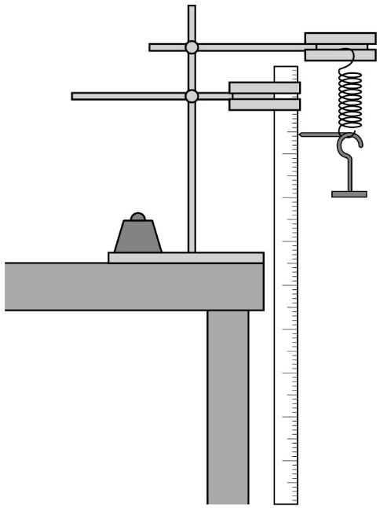

Trialling

The practical should be trialled before use with students.

GCSE Physics required practical activity: Force and Extension

Student sheet

Method

**You are provided with the following:**

* a spring
* a metre ruler
* a splint and tape to act as a pointer
* a 10 N weight stack
* a clamp stand, with two clamps and bosses
* a heavy weight to prevent the apparatus tipping over
* a mystery object to weigh.

**Read these instructions carefully before you start work.**

1. Attach the two clamps to the clamp stand using the bosses. The top clamp should be further out than the lower one.
2. Place the clamp stand near the edge of a bench. The ends of the clamps need to stick out beyond the bench.
3. Place a heavy weight on the base of the clamp stand to stop the clamp stand tipping over.

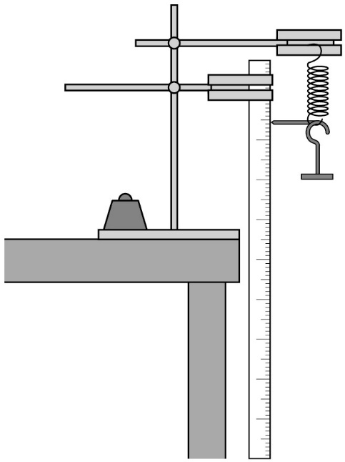

1. Hang the spring from the top clamp.
2. Attach the ruler to the bottom clamp with the zero on the scale at the top of the ruler.

If there are two scales going in opposite directions you will have to remember to read the one that increases going down.

1. Adjust the ruler so that it is vertical. The zero on the scale needs to be at the same height as the top of the spring.
2. Attach the splint securely to the bottom of the spring. Make sure that the splint is horizontal and that it rests against the scale of the ruler.
3. Take a reading on the ruler – this is the length of the unstretched spring.
4. Carefully hook the base of the weight stack onto the bottom of the spring. This weighs 1.0 newton (1.0 N).
5. Take a reading on the ruler – this is the length of the spring when a force of 1.0 N is applied to it.
6. Add further weights. Measure the length of the spring each time.
7. Record your results in a table such as the one below.

You will need a third column for the extension. This is the amount the string has stretched. To calculate this you subtract the length of the unstretched spring from each of your length readings.

|  |  |  |
| --- | --- | --- |
| **Weight in N** | **Length of spring in cm** | **Extension of spring in cm** |
|  |  |  |

1. Do not put the apparatus away yet.
2. Plot a graph with:

* ‘Extension of spring in cm’ on the y-axis
* ‘Weight in N’ on the x-axis.

1. Hang the unknown object on the spring. Measure the extension and use your graph to determine the object’s weight. Check it with a newtonmeter.